Memorandum Annex C
South East Blackburn Scheme

Economic Outputs Assessment
As part of our assurance of the SOBC documentation, a review was undertaken of the economic outputs that were provided to support the Economic Case.
A short summary of our review is provided below, indicating:
- Which Economic Outputs have been assessed;
- Which specific sites are in scope;
- The basis of the calculations for each output;
- How the economic outputs will be delivered;
- Certainty of delivery; and
- Monitoring and evaluation arrangements.

Economic Outputs
The following outputs have been assessed as part of the South East Blackburn Scheme, reflecting the requirements of the LEP:
- Housing Units;
- Private Sector Investment;
- Jobs;
- Commercial Floor Space; and ▪ GVA.
The South East Blackburn scheme is forecast to directly unlock 11 nearby development sites, comprising both residential and commercial uses, as shown on the plan overleaf:

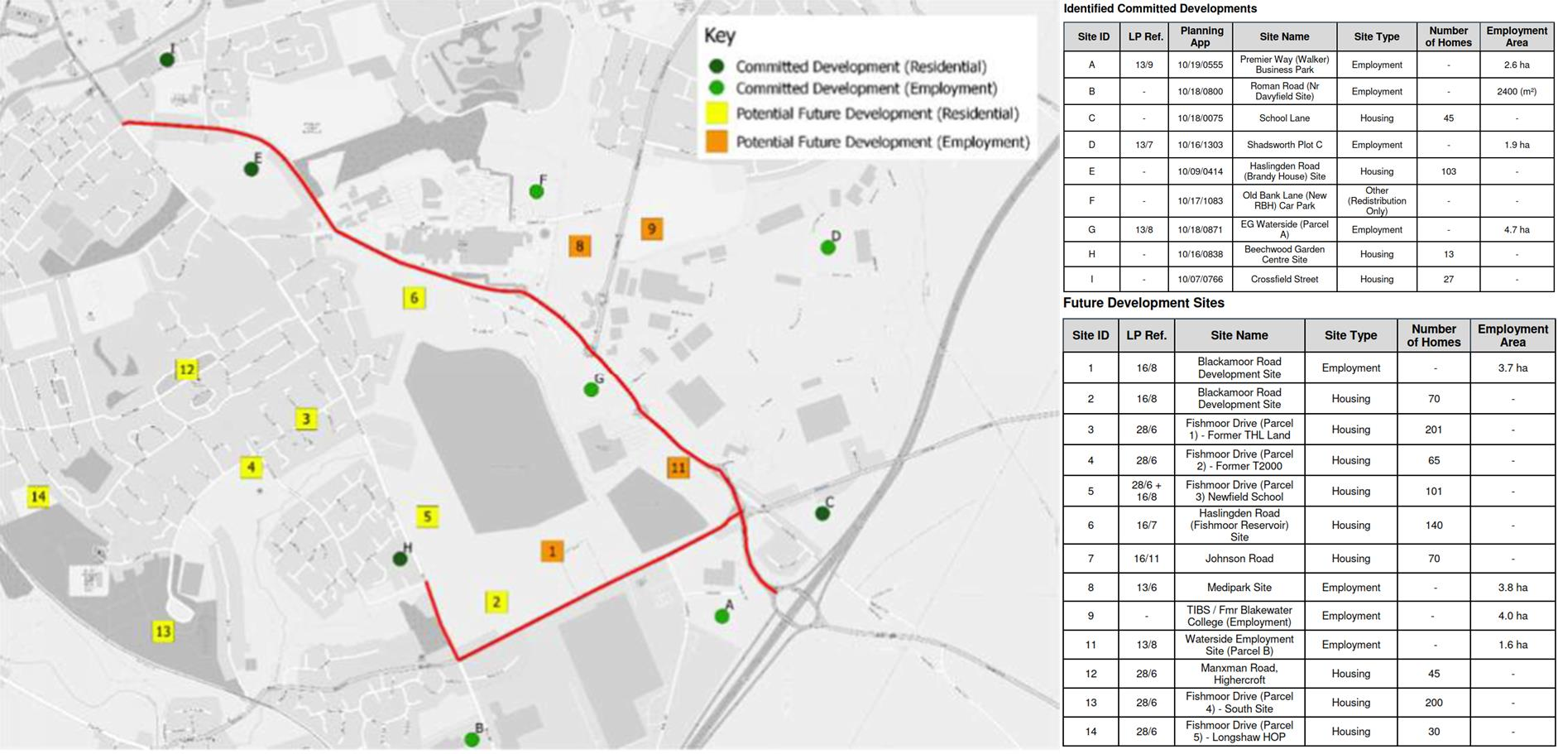

Memorandum

South East Blackburn Scheme

Calculations
The assumptions for each site are shown in the table below:

Table C1 – Development sites dependent on the South East Blackburn Scheme
Site | Site Area (Ha) | Dwellings | Floorspace | Jobs | Completion  Year
Blackamoor Road  Development Site | 6.82 | - | 37,600 | 1044 | 2025
Blackamoor Road  Development Site | 2.17 | 70 | - | - | 2025
Fishmoor Drive (Parcel 1) -  Former THL Land | 4.80 | 201 | - | - | 2025
Fishmoor Drive (Parcel 2) -  Former T2000 | 1.10 | 65 | - | - | 2023
Fishmoor Drive (Parcel 3)  Newfield School | 3.15 | 101 | - | - | 2025
Haslingden Road (Fishmoor  Reservoir) Site | 6.90 | 140 | - | - | 2025
Johnson Road | 7.60 | 70 | - | - | 2021
Medipark Site | 3.80 | - | 18,500 | 1542 | 2025
TIBS / Fmr Blakewater  College (Employment) | 4.00 | - | 19,500 | 542 | 2025
Waterside Employment Site  (Parcel A) - EG Waterside | 4.65 | - | 11,495 | 479 | 2019
Waterside Employment Site  (Parcel B) | 1.40 | - | 4,500 | 250 | 2021
Total | 46.39 | 647 | 91,595 | 3,857 | -
BwDBC have provided the assumptions around how many houses each development site will accommodate and the completion year.
The following assumptions and parameters have been used in calculation of the GVA benefits:
- GVA benefit per housing unit: £10,283 per annum
- GVA benefit per job created: £20,566 per annum
- Discount rate: 3.5% per annum
- Appraisal period: 15 years from scheme opening
The GVA appraisal tables, showing GVA per year and split by site, are provided as Appendix N to the SOBC.

Memorandum

South East Blackburn Scheme

Applying the discount rate to the ‘with scheme’ GVA benefits and adjusting for additionality (displacement and leakage) using an adjustment factor of 39% gives a total GVA benefit associated with the South East Blackburn scheme of £240m.

Certainty of Delivery
The calculation of economic benefits relies on assumptions about investments made by private companies in the future. These assumptions are therefore necessarily subject to uncertainty. In order to best assure the validity of the economic outputs, it is therefore important to base assumptions on the best available data, informed by local knowledge of the appetite of private developers for investment.

Monitoring and Evaluation
A Monitoring and Evaluation Plan has been developed by Capita for the South East Blackburn scheme, and forms Appendix C to the SOBC.
The Monitoring and Evaluation section of the SOBC (section 5.8) summarises the range of metrics which BwDBC aim to assess. The following metrics are relevant to the economic outputs section;
- Jobs connected to the intervention (annual): Rate of delivery to be monitored by BwDBC and reported.
- Commercial floorspace constructed (annual): Rate of delivery to be monitored by BwDBC and reported.
- Commercial floor space occupied (annual): to be identified and reported to the LEP annually.
- Housing unit starts (annual): Rate of delivery to be monitored by BwDBC and reported.
- Housing unit completed (annual): Rate of delivery to be monitored by BwDBC and reported.
- Follow-on investment at site (annual): Any further transport investment which may come via s106 contributions from developers to improve the active travel and public transport infrastructure in the local area will be monitored.
In addition, the Monitoring and Evaluation Plan makes clear that these metrics will be specifically monitored for the development sites identified as being dependent on the scheme.

